LABORATORY DIAGNOSTICS OF INFLAMMATION AND NON SPECIFIC INFLAMMATORY DISEASES OF GASTROINTESTINAL TRACT

Introduction
Inflammation is response of the body to homeostasis disorders of various origins: a pathogenic microorganisms (infection), tissue damage of non-infectious origin, caused by mechanical factors (injury - trauma), burns, poisons, metabolic stress, tissue hypoxia. Inflammatory reactions also occur in allergies and autoimmune diseases. Inflammation involves a large number of innate and adaptive immune responses.
Classic (basic) markers of inflammation: leukocytosis, ESR and CRP.
Despite the presence of a large number of biomarkers, which today can be determined using fast, accurate and automated platforms for diagnosing inflammation, classic laboratory methods for diagnosing inflammation, such as the increase in the number of white blood cells in a blood test and the rate of erythrocyte sedimentation (ESR), are still used as basic parameters in practice. These parameters are not specific, but due to their simple and inexpensive implementation, they are used to diagnose and control the dynamics of inflammatory reactions of different genesis.
Erythrocyte sedimentation rate (ESR)
Principle: Red blood cells carry negative charges on their surface, which means that they repel each other (Z-potential) and, despite their significantly higher density compared to plasma, their settling is delayed. inflammation makes red blood cells stick together in clumps. These clumps of cells are heavier than single cells, so they sink faster. Qualitative and quantitative changes in blood proteins during inflammation reduce the repulsion of red blood cells from each other and thereby accelerate their sedimentation. First of all, an increase in the blood content of fibrinogen, α2 -macroglobulin, immunoglobulins and other proteins of the acute phase of inflammation leads to an acceleration of ESR. The sedimentation rate is also influenced by the number, shape and deformability of red blood cells, as well as temperature.

Indications for determination of ESR
• For the diagnosis of inflammatory disease
• To control the dynamics of inflammatory disease

Table
Increase ESR | Decrease ESR
Inflammation
Alkalosis | Acidosis
Hyperhydration | Dehydration
Anemia | Erythrocytosis
Increased cholesterol | Increased lecithin and bile pigments

C-reactive protein (CRP)
CRP ̶ an acute phase protein of inflammation that, as a result of the action of cytokines IL-6 and IL-1β, is formed and released from liver cells. The CRP has sites of phosphocholine compounds through which it can bind to cell membranes of apoptotic cells and cell wall components, as well as additional sites for binding to the first complement system factor 1q (C1q) and to the Fc receptor. There are currently indications that CRP activates platelets, white blood cells, and endothelial cells.

Special inflammatory markers: IL-6 and Procalcitonin
Special markers of inflammation include IL-6 and Procalcitonin. The purpose of using special inflammatory markers is to detect inflammation early and differentiate into infectious or non-infectious inflammation. Another goal of identifying specific inflammatory markers is to assess risk and predict the outcome of inflammation, and to select and monitor specific patient populations for specific therapies.

Interleukin 6 (IL-6)
Interleukin 6 (IL-6) is produced by stimulated monocytes/macrophages, fibroblasts and endothelial cells. T and B lymphocytes, mast cells, glial cells and keratinocytes are able to release IL-6 after appropriate stimulation. IL-6, along with IL-3, supports the proliferation of multipotent hematopoietic progenitor cells, acts as thrombopoietin and as a B-cell differentiation factor. IL-6 acts as a mediator of acute phase inflammation reactions, stimulates the synthesis of acute phase proteins by hepatocytes, and therefore is also the "initiator" of CRP elevation. An increase in IL-6 in the blood occurs as early as 2-4 hours after the start of the acute inflammatory process. IL-6 increases in proportion to the severity of inflammation, but does not provide any information on the cause of inflammation.
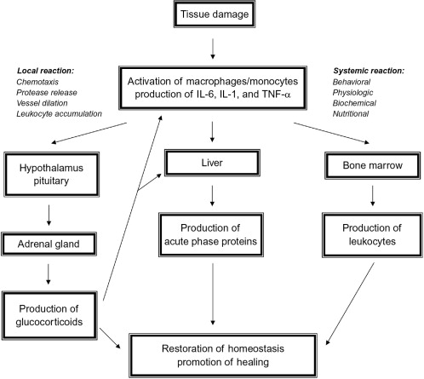

Procalcitonin (PCТ)
PCT is a complex glycoprotein, a precursor to the thyroid hormone calcitonin, as well as an indicator of the systemic inflammatory process in the body, is superior in sensitivity and specificity to inflammatory markers - CRP and IL-6. In the presence of systemic inflammation, PCT is formed not only in the thyroid gland, but also in RES cells (reticulo-endothelial system). The main activators of these processes are TNF-α, IL-6, as well as LPS (liposaccharides) of Gram-negative bacteria.
Normally, the PCT content in the blood is extremely low. The amount of procalcitonin in a healthy person is less than 0.5μg/l. In bacterial infections, PCT levels increase significantly.
Causes of blood procalcitonin increase
1. increased procalcitonin levels associated with infections: sepsis with confirmed or unconfirmed bacterial infection, sepsis-related conditions such as acute pancreatitis, systemic infections that can occur in pneumonia or acute pyelonephritis, systemic viremias, fungal infections, severe malaria;
2. increased procalcitonin levels not associated with infections: burns, injuries, sunstroke, heatstroke;
3. increased procalcitonin levels associated with diseases of respiratory system: aspiration and inhalation pneumonia, adult respiratory distress syndrome (ARDS), pulmonary neuroendocrine hyperplasia occurring in chronic obstructive pulmonary disease (COPD) or chronic bronchitis associated with smoking;
4. increased procalcitonin associated with malignant tumors: medullary thyroid cancer (C-cell thyroid cancer), small cell lung cancer, non-small cell lung cancer, carcinoid tumor, other neuroendocrine tumors (pheochromocytoma, insulinoma), breast cancer;
5. severe chronic renal failure.
The concentration of glycoprotein rises slightly if the patient has allergies, viral, fungal diseases, autoimmune abnormalities, while the PCT level reaches more than 0.5μg/l. In burns complicated by purulent-septic diseases, in the presence of malignant tumors in the lungs and thyroid gland, the PCT content rises above 10-20 μg/l. It is characteristic that the more severe the infection, the higher the level of procalcitonin.
N | < 0,5 μg/l
A | Indications for definition: differentiation of fever of bacterial and non-bacterial origin
↑ | At > 5μg/l indicates sepsis; differentiation of infection of viral (normal or slightly increased) and bacterial (significant increase) origin; indicates multiple organ failure

Immunoglobulins (Ig) and Paraproteins
Indications for determination of Ig and paraproteins:
• Clinical signs of immunodeficiency, possibly due to decreased γ-globulin levels in serum electrophoresis;
• Detection of intrauterine infections in newborns;
• Increase in β- or γ-globulins in serum electrophoresis;
• M-gradient in serum electrophoresis;
• Clinical symptoms (bone pain, rheumatic complaints, anemia, especially in elderly patients) associated with increased ESR, proteinuria;
• Renal failure of unknown origin.
Research Material and Preanalyst
• serum or blood plasma.
Immunoglobulins are also determined for the diagnosis of hypersensitivity reactions:
- Allergies (IgE-dependent allergic reactions, IgE-independent allergic reactions of type III and IV)
- Autoantibodies (Rheumatoid factor RF, Autoantibodies against citrullinated peptides/proteins-ACPA, Antinuclear antibodies - ANA, Antineutrophil cytoplasmic antibodies ANCA, Antimitochondrial antibodies AMA, Antibodies to smooth muscle cells - ASMA)

Hypoalbuminemia is observed in fasting, exudative enteropathy, acute infections, nephrotic syndrome, cirrhosis, hepatitis, malignoma.

Hyperalbuminemia is not clinically relevant (relative elevation observed with dehydration).

Autoimmune gastritis
Autoimmune gastritis (type A of chronic gastritis) results from the production of autoantibodies (mainly immunoglobulin G, infiltrates of plasma cells, and B lymphocytes) to the parts and products of gastric parietal cells, including antibodies against the acidproducing enzyme H⁺,K⁺ -ATPase, gastrin receptor, and Castle’s intrinsic factor (IF). The autoimmune injury leads to gland destruction and mucosal atrophy, with concomitant loss of acid (achlorhydria) and intrinsic factor production. IF antibodies also block the binding of cobalamines (vitamin B12) to IF or the uptake of IF–cobalamine complexes by cells in the ileum, ultimately resulting in cobalamine deficiency with pernicious anemia. In atrophic gastritis more gastrin is liberated in response to this, and the gastrin-forming cells hypertrophy. Hyperplasia of the enterochromaffin-like (ECL) cells occurs, probably as a consequence of the high level of gastrin.
This form of gastritis is seen in association with other autoimmune disorders such as Hashimoto thyroiditis, Addison disease, and type 1 diabetes. Patients with autoimmune gastritis have a significant risk for developing gastric carcinoma and endocrine tumors (carcinoid tumor), presumably due to chronic inflammation and intestinal metaplasia.
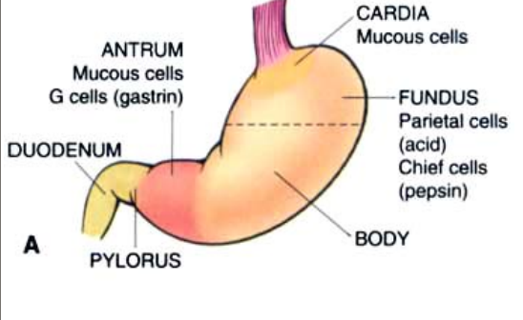
Clinical signs. Atrophy of the gastric mucosa develops within 20-30 years, and anemia occurs only in a small number of patients. Due to the variability of the course of the disease and the absence of obvious symptoms, autoimmune gastritis is usually diagnosed many years after its manifestation. More often autoimmune gastritis is detected in female patients. Clinical manifestations of autoimmune gastritis may be represented by symptoms of pernicious anemia. In addition, vitamin B12 deficiency can cause atrophic glossitis (the tongue becomes smooth and turns bright red), as well as epithelial megaloblastosis and diarrhea resulting from impaired absorption (malabsorption). Vitamin B12 deficiency can cause peripheral neuropathy due to demyelination, axonal degeneration, spinal cord damage, and impaired CNS function. The most common manifestations of peripheral neuropathy are paresthesia and numbness.
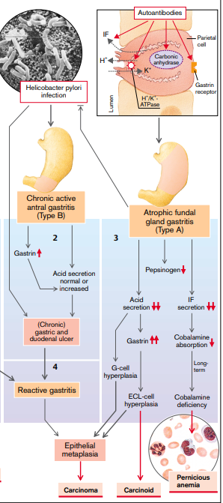
Autoimmune gastritis is characterized by:
- presence of antibodies to parietal cells and IF in serum and gastric juice;
- decrease of pepsinogen concentration in blood serum;
- hyperplasia of endocrine cells in the antrum of the stomach;
- vitamin B12 deficiency;
- impaired secretion of hydrochloric acid in the stomach (achlorhydria).

Celiac disease.
Celiac disease, also known as non-tropical sprue or gluten-sensitive enteropathy, is an immune-mediated enteropathy caused by eating gluten-containing cereals (wheat, rye, or barley). Celiac disease develops only in genetically predisposed people (HLA-DQ2 genes, HLA-DQ8).
Pathogenesis. Celiac disease is an immune disease of the small intestine, the cause of which is gluten. Gluten is the main protein of wheat grains and cereals similar to it, and the alcohol-soluble gluten fraction, gliadin, contains components that cause the development of the disease. Gluten is broken down by enzymes in the intestinal lumen to amino acids and peptides, including a α-gliadin peptide resistant to cleavage by proteases of the stomach, pancreas and small intestine (Figure 1).

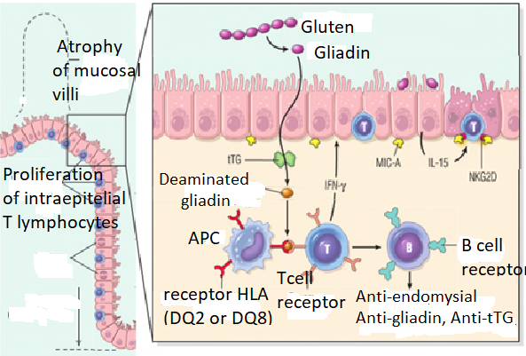
Fig.1 Pathogenesis of celiac disease.

A chain of immune responses to gliadin leading to the development of celiac disease. Some gliadin peptides induce expression by epithelial cells of IL-15, which in turn triggers the activation and proliferation of intraepithelial T lymphocytes CD8+, causing them to express NKG2D (a marker of NK cells). Such lymphocytes become cytotoxic and kill enterocytes with surface MIC-A (which is an HLA-1-like protein expressed in response to damage) because NKG2D serves as a receptor for MIC-A. CD8+ NKG2D+ T cells do not recognize gliadin, unlike CD4+ T cells. Epithelial damage allows other gliadin peptides to pass through epitheliocytes to the intestinal wall, where gliadin peptides are deaminated by tissue transglutaminases (tTG). Deaminated gliadin peptides are capable of interacting with HLA-DQ2 or HLA-DQ8 receptors on antigen presenting cells (APC) that present gliadin peptides to CD4+ T cells. These T cells produce cytokines that promote tissue damage and mucosal alteration (Fig.1).
Almost all people eat bread and are exposed to gluten and gliadin, however most celiac disease does not develop. Thus, it depends on the internal factors of the human body whether this disease develops or not. Among these factors, HLA proteins are crucial, since almost all patients with celiac disease have alleles of HLA-DQ2 or HLA-DQ8 classII. The HLA system is responsible for at least 50% of cases of celiac disease. Other genetic factors are probably the polymorphism of immunoregulatory genes, for example those that encode the synthesis of IL-2, IL-21, CCR3 and SH2B3, as well as genes that determine the polarity of the epithelium.
Celiac disease is associated with other immune diseases: type 1 diabetes mellitus, thyroiditis, Sjögren's syndrome, as well as ataxia, autism, depression, some forms of epilepsy, IgA nephropathy, Down syndrome and Shereshevsky-Turner syndrome.
Clinical signs. In adults, celiac disease usually develops at the age of 30-60 years. However, due to its atypical manifestations, it is not possible to diagnose the disease for a long time. In some patients, celiac disease has a latent course, and the disease can only be detected by positive results from a serological study and atrophy of intestinal villi. Symptomatic celiac disease in adults is often accompanied by anemia, chronic diarrhea, flatulence, and chronic fatigue syndrome. Celiac disease is 2-3 times more likely to be detected in women, probably due to the fact that their menstrual bleeding increases the need for iron and vitamins and exacerbates the effect of impaired absorption.
Celiac disease with classic symptoms usually manifests in children aged 6-24 months after the introduction of gluten-containing foods into their diet, and is manifested by irritability, flatulence, anorexia, chronic diarrhea, poor body weight gain or loss, muscle exhaustion. Celiac disease with non-classical symptoms is usually seen in older children and is characterized by abdominal pain, nausea, vomiting, flatulence, and constipation. Extra-intestinal manifestations - arthritis or joint pain, epileptic seizures, aphthous stomatitis, iron deficiency anemia, slowing puberty and growth. Skin itching, blistering skin damage and dermatitis herpetiformis have 10% of patients, lymphocytic gastritis and lymphocytic colitis can also develop. Currently, the only possible treatment for celiac disease is a gluten-free diet, which, despite some difficulties in following it, improves the condition of most patients. The gluten-free diet also reduces the risk of long-term complications, particularly anemia, female infertility, osteoporosis and malignant tumor.
Laboratory diagnostics. For the diagnosis of celiac disease, it is important to obtain and examine a biopsy from the descending part of the duodenum or proximal jejunum that is most exposed to gluten. Pathological changes: intraepithelial lymphocytosis (an increase in the number of intraepithelial CD8+ T cells), hyperplasia of intestinal crypts and atrophy of intestinal villi. The pathological changes of the mucous membrane lead to the development of malabsorption. The most specific for celiac disease is the combination of both histological and serological features.
Prior to biopsy of the duodenal mucus, a non-invasive serological examination is usually performed. The most sensitive test is the detection of IgA antibodies to tissue transglutaminases or IgA/IgG antibodies to deaminated gliadin. Anti-endomysial antibodies are highly specific but less sensitive than other antibodies. When testing negative for IgA antibodies, it is important to rule out IgA deficiency, which often develops in patients with celiac disease. In IgA deficiency, it is necessary to measure the titers of IgG antibodies to tTG and deaminated gliadin. The absence of HLA-DQ2 and HLA-DQ8 indicates the absence of the disease, however, the presence of these alleles does not confirm the diagnosis of celiac disease; signs of celiac disease develop in only 1% of patients with HLA-DQ2/DQ8.
Use of serum antibodies for the diagnosis of celiac disease:
• IgA endomysial antibodies (IgA EMA; moderately sensitive and highly specific in untreated (active) celiac disease). The test results are assessed simply - as positive or negative, since even low titers of serum IgA endomysial antibodies are specific for celiac disease.
• IgA tissue transglutaminase antibodies (IgA tTG).Anti-tTG antibodies are highly sensitive and specific for the diagnosis of сeliac disease.
• IgA antiglyadine antibodies (IgA AGA). Although these tests demonstrate moderate sensitivity and specificity (especially IgA), their value as an indicator of disease in the general population is relatively low.
• IgG antiglyadine antibodies (Ig G AGA). AGA tests are not currently recommended for use due to their low sensitivity and specificity.
Dermatitis herpetiformis is associated with IgA antibodies against epidermal transglutaminase (eTG), which does not occur in celiac disease.
Patients with herpetiform dermatitis with abnormal blood results usually undergo a biopsy of the small intestine to confirm gluten-sensitive enteropathy.
Specific tests for herpetiform dermatitis with celiac disease:
• IgA anti-endomysial antibodies
• IgA, tTG antibodies
• IgA antibodies to epidermal transglutaminase *, eTG (if present)
• IgA and IgG antibodies to deaminated gliadin peptides, dGP
• Total IgA level
• HLA haplotype, a set of DNA variations, testing can reveal HLA-DQ2 (90-95% of cases) or HLA-DQ8. This is present in almost all patients with dermatitis herpetiformis (and celiac disease).
• Complete blood count, liver function tests and serum calcium levels
• Iron, zinc, vitamin B12 and folic acid
• Thyroid function tests.
Mild anemia may be caused by iron or folic acid deficiency (or both) due to malabsorption associated with gluten-sensitive enteropathy. Thyroid function tests are usually recommended because of the association between dermatitis herpetiformis and thyroid disease.
Individuals with celiac disease have a higher risk of developing malignancies: enteropathy-associated T-cell lymphoma, small intestine adenocarcinoma.

Nonspecific inflammatory bowel disease (IBD)
IBD is a chronic disease resulting from inadequate activation of the immune defense components of the intestinal mucosa. IBD is represented by two diseases - Crohn's disease (CD) and nonspecific ulcerative colitis (UC). The difference between CD and UC is shown in Fig. 2.
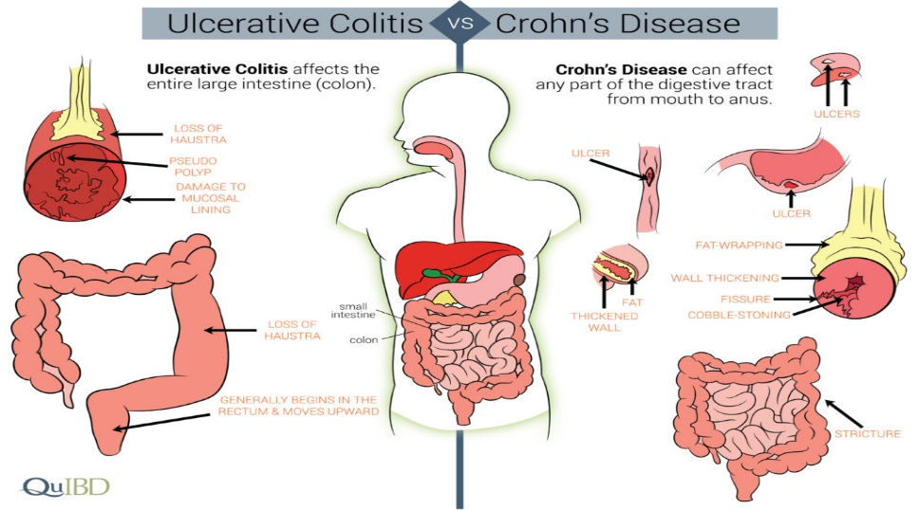

Fig.2. Difference between CD and UC.

IBD is an idiopathic disease, its causes and pathogenesis are not yet well understood. Possible triggers of IBD: microorganisms (infections), stress, smoking, previous drug treatment, nutritional features, defects of the immune system.
Factors involved in the pathogenesis of IBD: genetic factors, disorders of the immune response of the intestinal mucosa, defects in epithelial cells, intestinal microflora.
Genetic predisposition plays a role in the pathogenesis of IBD. In keeping with an underlying immunologic dysfunction, both CD and UC have been linked to specific MHC II alleles. UC has been associated with HLA-DRB1, whereas HLA-DR7 and DQ4 alleles are associated with approximately 30% of cases with CD.
There is also the associations of the disease with non-HLA genes. Polymorphism and mutation of genes responsible for immune regulation, mucosal integrity, transepithelial transport, recognition and destruction of intracellular microorganism pathogens and/or intestinal homeostasis may cause the development of IBD. In particular, it has been found that in diseases associated with NOD2 polymorphisms (TLR- toll like receptors), the human body is more difficult to recognize and destroy pathogenic intestinal microflora. The NOD2 protein is an intracellular receptor for muramyl dipeptide, a component of the cell walls of many bacteria, and is thought to play a role in host responses to these bacteria. The NOD2 is expressed in Paneth cells. The mutation of NOD2 leads to the penetration of microorganisms into the own plate of the intestinal mucosa and triggers an inflammatory reaction. However, NOD2 polymorphisms affect mostly the pathogenesis of Crohn's disease, the disease develops in 25% of individuals with NOD2 mutations. This supports the fact that other factors also play an equally important role in the pathogenesis of IBD. The fact that NOD2, ATG16L1, and IRGM are involved in the recognition and destruction of intracellular pathogens supports the hypothesis that an excessive immune response to intestinal microflora is an important component of the pathogenesis of IBD.
Immune response of the intestinal mucosa in IBD.
In Crohn's disease, the involvement of Th1 cells is clearly established (delayed type hypersensitivity reaction), but some data suggest that Th17 cells are also involved in the pathogenesis of the disease. The pathogenesis of CD is influenced by IL-23. IL-23 is a cytokine that promotes the production of IL-17 by T cells, and IL-17 has been implicated in inflammatory reactions in IBD. Some polymorphisms of the IL-23 receptor provide protection against Crohn's disease by weakening the pro-inflammatory response of Th17 cells.
Some data indicate that UC is a Th2-mediated disease, consistent with observations of increased mucosal IL-13 concentrations in patients with UC. The polymorphisms of IL-10 gene indicate the importance of the immune regulatory system in the pathogenesis of UC (but not in Crohn's disease). There are probably combinations of disorders that activate mucosal immunity and suppress immunoregulatory effects, which leads to the development of UC and Crohn's disease. Currently, the subject of close attention is the study of the possible role of disorders of innate and acquired immunity in IBD.
Inflammation of the intestinal mucosa leads to a violation of the balance of cytokines, which determines the characteristics of the course of IBD. Changes in cytokine regulation consist in an increase in the production of inflammatory cytokines, primarily TNF- α, as well as IL-1, -6, -8, -12 with a decrease in anti-inflammatory interleukins -4, -10, -11, as well as a pronounced imbalance of regulatory cytokines IL-2, -5. One of the most active cytokines with pro-inflammatory effects is TNF-α, which together with IFN-γ and IL-1 mediates delayed hypersensitivity responses and macrophage activation, which leads to the formation of granulomas in CD. In inflammation, this cytokine stimulates Th1 lymphocytes and macrophages, induces systemic reactions of the acute phase with increased synthesis of IL-1, -2, -6, -8. The increase in IL-2 stimulates the proliferation of T-lymphocytes and B-lymphocytes, the functional activity of natural killers, leads to the activation of macrophages, which means clonal proliferation and differentiation of lymphocytes, and IL-8 stimulates chemotaxis and causes the activation of T-lymphocytes with the formation of oxygen radicals and the release of lysosomal enzymes.
Various defects of epithelial cells have been described in CD and UC. Disorders of epithelial function, transepithelial transport, mucus secretion due to the mutation of the YeSM1 gene, which plays the role of an extracellular barrier, a large number of metalloproteinases (MMP) that cause destruction of the extracellular matrix and basement membranes, as well as disorders of the antimicrobial function of the intestinal epithelium due to a decrease in the content of antibacterial peptides of defensins in the epithelium play an important role in pathogenesis of IBD.
Intestinal microflora. In addition to microflora living in the intestinal lumen, there is a limited population of microorganisms living in the intestinal mucosa and, possibly, having an effect on human health. The incidence of microbiota disorders in IBD reaches 66-93%. Autoimmunization, as well as a high concentration of circulating immune complexes (CECs), indicate a selective loss of immunological tolerance to normal intestinal flora, ultimately leading to an intense inflammatory process. Thus, in patients with Crohn's disease, the presence of antibodies to the bacterial protein flagellin is associated with polymorphisms of NOD2, as well as with the formation of strictures, perforations and involvement in the process of the small intestine, but this association is rarely observed in patients with UC. Studies to date have found that probiotics (beneficial bacteria) are effective for the treatment of the disease in both the experiment and in patients with IBD, although the mechanism of action of probiotics is not clear enough.
In one of the animal models of the disease, taking into account the roles of intestinal microflora, disorders of epithelial function and the immune response of the mucous membrane, the presence of a cyclic process in which the transepithelial transition of bacteria from the intestinal lumen activates innate and acquired immunity was investigated.
In individuals with genetic predisposition, the release of TNF and other immune-mediated signaling molecules by epithelium increases the permeability of tight contacts, which increases the number of microorganisms penetrating the epithelium. Such changes can lead to the formation of a vicious circle in which stimulation of any of the pathogenetic units causes the development of IBD. This model helps to understand the pathogenesis of IBD.
Many factors are involved in the development of IBD. For example, after appendectomy, the risk of developing CD increases, that’s why appendectomy should be avoided in the absence of appendicitis. At the same time meta‐analyses of case–control studies have concluded that UC was significantly lower after previous appendectomy. Smoking also alters the epidemiology of IBD, but paradoxically: the risk of Crohn's disease increases and the risk of UC decreases.
The features of CD and UC are compared in Table 2.
Table2.
Feature | Crohn disease | Ulcerative colitis
Bowel region | Ileum±Colon | Colon
Stricture | Early | Late/rare
Wall appearance | Thickened | Thin
Dilation | No | Yes
Pseudopolypen | None | Marked
Ulcer | Deep, linear | Superficial
Granulomas | Yes | No
Fistulas | Yes | No
Fat/vitamin malabsorbtion | Yes | No
Malignant potential | Yes | Yes
Response to surgery | Poor | Good

Crohn's disease
Crohn's disease (CD) is characterized by transmural damage, in which the inflammatory process captures all layers of the intestinal wall. Crohn's disease can affect any part of the gastrointestinal tract, from oral cavity to anus, but most commonly the pathological process is located at the terminal ileum. A characteristic feature of CD is multiple isolated, clearly delimited from the unchanged mucosa segmental lesions, which helps with differential diagnosis with UC. Often, intestinal strictures form.
CD is characterized by:
- aphthous ulcer (the earliest lesion in CD). Small scattered areas of unchanged mucosa, located between chaotically scattered areas of damage, create the appearance of a "cobblestone bridge" - the affected tissue is located below the level of the normal mucosa.
- epithelial metaplasia often occurs by the type of formation of glands similar to the antral glands of the stomach, which is called pseudopyloric metaplasia. Years after the onset of the disease, mucosal atrophy may develop with the disappearance of crypts.
- non-caseating granulomas with macrophages, giant and epithelioid cells - pathognomonic sign of CD.
- fistula formation.
Clinical signs of CD are very diverse. In most patients, the disease begins with periodic attacks of relatively mild diarrhea, fever, and crampy abdominal pain. Periods of active disease usually alternate with periods of asymptomatic course, which last from several weeks to several months. Exacerbation of the disease can be associated with various external stimuli, including physical and emotional stresses, diet features, and smoking (it’s a strong exogenous risk factor for Crohn's disease). Unfortunately, smoking cessation does not lead to remission.
During periods of exacerbation, a laboratory blood test shows an increase in the classical and specific parameters of inflammation. Individuals with colon lesions may develop iron deficiency anemia, and common small intestine lesions may result in significant protein loss, hypoalbuminemia, impaired absorption of all nutrients, or vitamin B12 and bile acid salts alone. Fibrotic strictures are often formed, especially in the terminal ileum, in which surgery is necessary. Fistulae form between the loops of the intestine, which can involve the bladder, vagina, skin of the abdominal wall and perianal region. Perforation and peritoneal abscesses are observed often. Patients with long-term colon disease have an increased risk of adenocarcinoma.

Ulcerative colitis
UC (ulcerative colitis) is a severe inflammatory disease that is limited to the colon and rectum and involves only their mucous membrane and submucosal layer in the pathological process. UC resembles Crohn's disease, however, in UC, the lesion is limited only to the colon and rectum. Involvement in the pathological process of the entire colon is called pancolitis. Limited involvement of the distal colon can occur in the form of ulcerative proctitis or ulcerative proctosigmoiditis.
Extraintestinal manifestations of UC and Crohn's disease are similar and include migratory polyarthritis, sacroileitis, ankylosing spondylitis, uveitis, erythema nodosa, pericholangitis, and primary sclerosing cholangitis (more characteristic of UC). Morphological changes in UC include:
- longitudinal ulcers
- pseudopolypes, which, like the islands of the regenerating mucosa, protrude into the intestinal lumen. In UC, unlike CD, the intestinal wall is not thickened, the serous membrane is not changed, there are no strictures. However, inflammation can lead to damage to the muscle layer of the wall and disrupt neuromuscular communication, which leads to colon dilation (toxic megacolon), in which there is a very high risk of perforation. After treatment, submucous fibrosis, atrophy and mucosal impairment are observed as residual events. After prolonged remission, the structure of the intestinal wall can become almost normal.
Clinical signs. UC is a chronic relapsing disease characterized by bloody diarrhea with viscous mucus, pain in the lower abdomen and cramps that temporarily weaken after bowel movements. These symptoms can persist for days, weeks, or even months. Removal of the colon in UC is an effective treatment, but extraintestinal manifestations may remain. There is evidence that in some patients, the initial symptoms of the disease appear a short time after smoking cessation (smoking may partially alleviate the symptoms of the disease, but is not a method of therapy).
In ~ 10% of patients with IBD, the final diagnosis cannot be established, since they have overlapping clinical and pathological signs of UC and CD. Serological studies are useful in such observations of the so-called indeterminate colitis, since perinuclear antineutrophil cytoplasmic antibodies (pANCAs) are determined in 75% of persons with UC and only in 11% with Crohn's disease. Patients with UC usually lack antibodies to S. cerevisiae, often detected in patients with Crohn's disease.
The most serious complication is the increased risk of carcinoma. Immunosuppression is one of the treatments for IBD.

